CentOS系统
#rpm的使用

-qc 列出所有的配置文件
-qf
-ql 列出所有文件
-qi 列出相关信息

#ps -ef | grep “/usr/sbin/httpd” 判断返回值是否为>1，如果是大于1则为rpm安装；如果等于1则需要判断是否为编译安装

httpd的检测
备注 ：httpd的vhost的配置都集中在httpd.conf配置文件中

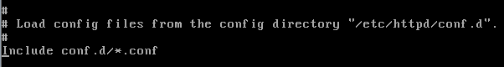

1.1RPM安装方式检测

&定位配置文件

#rpm -qc httpd | grep ‘httpd\.conf’

&判断是否使用的vhost

#grep -v ‘^#’ /etc/httpd/conf/httpd.conf | grep “NameVirtualHost”

备注：如果启用了vhost，那么默认的/var/www/html 就会失效。

&判断vhost的数量

#grep -v ‘^#’ /etc/httpd/conf/httpd.conf | grep ‘<VirtualHost’

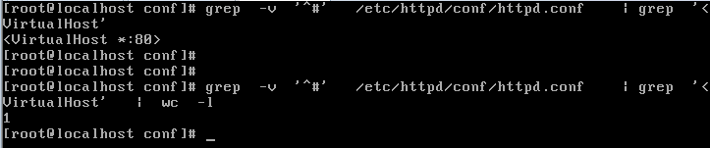

&判断vhost的域名

#grep -v ‘^#’ /etc/httpd/conf/httpd.conf | grep ‘ServerName’ | awk ‘{print $2}’

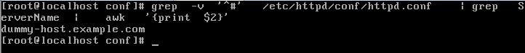

&判断vhost的网站目录（每个域名的网站目录，多个域名时可能要用到for循环）

需要判断/var/www/html目录

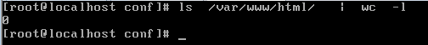

如有/var/www/html目录有文件

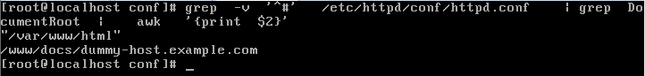

如果/var/www/html目录无文件

&截取到的域名和目录名称应该是按照顺序一一对应的

#sed -n '1p' test.c 得到域名，和目录

1.2make&make install方式检测
安装编译环境

# yum install -y gcc
# yum install apr-*

下载源码

# wget http://mirrors.cnnic.cn/apache/httpd/httpd-2.2.26.tar.gz

解压源码包

# tar -zxf httpd-2.2.26.tar.gz

进入源码包目录

# cd httpd-2.2.26

编译apache

# ./configure --help

# ./configure --prefix=/usr/local/apache

# make && make install

启动http服务|停止

# /usr/local/apache/bin/apachectl start/stop

./icons #Apache图标文件目录
./modules #动态加载模块目录
./lib #库文件目录
./logs #日志文件目录
./build #
./conf #主配置文件目录
./conf/extra #扩展及模块配置文件目录
./conf/original #用于存放 extra目录和httpd.conf的备份
./error #默认错误应答文件目录
./manual #Apache文档目录
./include #包含头文件目录
./htdocs #默认WEB文档根目录
./cgi-bin #默认cgi文件目录
./bin #Apache二进制程序及服务程序目录
./man #man帮助文件目录

获取编译时的参数

# find / -name "config.nice" | grep "build"

/usr/local/apache/build/config.nice

# cat /usr/local/apache/build/config.nice

#! /bin/sh
#
# Created by configure

"./configure" \
"--prefix=/usr/local/apache" \
"$@"

#grep "prefix=" /usr/local/apache/build/config.nice

"--prefix=/usr/local/apache" \

得到编译安装的安装目录

# grep "prefix=" /usr/local/apache/build/config.nice | awk -F"=" '{print $2}' | awk -F'"' '{print $1}'

/usr/local/apache

如果没有手动指定

A typical installation might use "/usr/local/apache2" for PREFIX (without the quotes).

------------以上操作获取apache的安装目录

配置文件的路径

conf/httpd.conf

# cat htdocs/index.html 默认主页存放目录
<html><body><h1>It works!</h1></body></html>

# ls /usr/local/apache/conf/extra
httpd-autoindex.conf httpd-languages.conf httpd-ssl.conf
httpd-dav.conf httpd-manual.conf httpd-userdir.conf
httpd-default.conf httpd-mpm.conf httpd-vhosts.conf
httpd-info.conf httpd-multilang-errordoc.conf

判断vhost功能是否开启,默认不开启

# Virtual hosts
#Include conf/extra/httpd-vhosts.conf

开启的话：
- vhost 都在 httpd-vhosts.conf文件中 OK
- vhost放到了httpd.conf中，httpd-vhosts.conf中的vhost删除 OK
- httpd.conf 和 httpd-vhost.conf 中都有vhost OK
- 专门有指定了 Include 相对路径 文件、目录 绝对的文件、目录
如：
Include conf/vhost/*.conf OK

查看是否有人为加入的Include

#grep -v “^#” /usr/local/apache/conf/httpd.conf | grep “Include ”

主配置文件httpd.conf中有如下配置，

<Directory />
Options FollowSymLinks
AllowOverride None
Order deny,allow
Deny from all
</Directory>

导致添加vhost后，访问页面

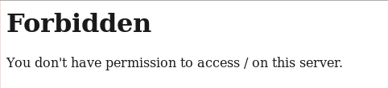

日志报错：

[Tue Nov 26 23:12:22 2013] [error] [client 192.168.3.205] client denied by server configuration: /usr/local/apache/docs/vhost-1/

解决方法：去掉标注的参数，并重启http服务

验证在httpd.conf中设置vhost，会将将原有的默认页面覆盖

<VirtualHost *:80>
ServerAdmin webmaster@dummy-host2.example.com
DocumentRoot "/usr/local/apache/docs/vhost-1"
ServerName vhost-1.hongxin.com
ErrorLog "logs/dummy-host2.example.com-error_log"
CustomLog "logs/dummy-host2.example.com-access_log" common
</VirtualHost>

并查看被包含的路径文件中

-----------以上得到vhost的配置文件

有配置文件得到各个vhost的域名和目录位置

统计共有多少vhost

1.3两种安装方式的检测

nginx的检测

nginx和apache 的虚拟主机开启的条件是有区别的，apache判断 NameVirtualHost是否起效，而nginx不用判断

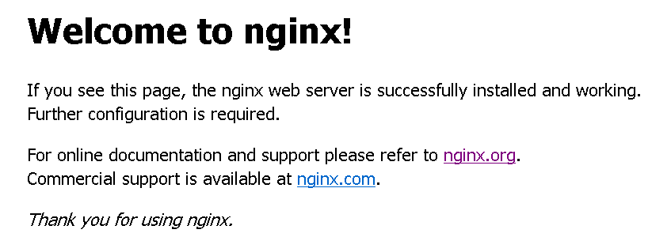
备注：正常情况下/etc/nginx/conf.d/default.conf 中默认的网页需要修改

2.1RPM安装方式

nginx安装

# wget http://nginx.org/packages/rhel/6/noarch/RPMS/nginx-release-rhel-6-0.el6.ngx.noarch.rpm

# rpm -ivh nginx-release-rhel-6-0.el6.ngx.noarch.rpm

warning: nginx-release-rhel-6-0.el6.ngx.noarch.rpm: Header V4 RSA/SHA1 Signature, key ID 7bd9bf62: NOKEY
Preparing... ########################################### [100%]
1:nginx-release-rhel ########################################### [100%]

# yum install -y nginx

验证nginx安装

# rpm -qa | grep nginx

nginx-1.4.4-1.el6.ngx.x86_64
nginx-release-rhel-6-0.el6.ngx.noarch

基本目录

/etc/nginx

# rpm -qc nginx | grep "nginx\.conf" 定位主配置文件
/etc/nginx/nginx.conf

web site 关键字 “server” （注意必须是小写）

# /etc/init.d/nginx restart
nginx: [emerg] unknown directive "Server" in /etc/nginx/conf.d/default.conf:1
nginx: configuration file /etc/nginx/nginx.conf test failed

2.2Make Install
安装nginx编译依赖包

# yum install pcre-devel -y
# yum install zlib-devel -y

下载nginx
#wget http://nginx.org/download/nginx-1.4.2.tar.gz
解压nginx
# tar -zxvf nginx-1.4.2.tar.gz

目录重命名
# mv nginx-1.4.2 nginx

# apt-get install -y libpcre3-dev
# apt-get install -y libghc-zlib-dev

编译选项配置，这里从简
# cd nginx
# ./configure --prefix=/usr/local/nginx

nginx path prefix: "/usr/local/nginx"
nginx binary file: "/usr/local/nginx/sbin/nginx"
nginx configuration prefix: "/usr/local/nginx/conf"
nginx configuration file: "/usr/local/nginx/conf/nginx.conf"
nginx pid file: "/usr/local/nginx/logs/nginx.pid"
nginx error log file: "/usr/local/nginx/logs/error.log"
nginx http access log file: "/usr/local/nginx/logs/access.log"
nginx http client request body temporary files: "client_body_temp"
nginx http proxy temporary files: "proxy_temp"
nginx http fastcgi temporary files: "fastcgi_temp"
nginx http uwsgi temporary files: "uwsgi_temp"
nginx http scgi temporary files: "scgi_temp"

特别需要注意的是，不论是否重命名nginx目录，如果不手动指定prefix（安装目录）

nginx path prefix: "/usr/local/nginx"
nginx binary file: "/usr/local/nginx/sbin/nginx"
nginx configuration prefix: "/usr/local/nginx/conf"
nginx configuration file: "/usr/local/nginx/conf/nginx.conf"
nginx pid file: "/usr/local/nginx/logs/nginx.pid"
nginx error log file: "/usr/local/nginx/logs/error.log"
nginx http access log file: "/usr/local/nginx/logs/access.log"
nginx http client request body temporary files: "client_body_temp"
nginx http proxy temporary files: "proxy_temp"
nginx http fastcgi temporary files: "fastcgi_temp"
nginx http uwsgi temporary files: "uwsgi_temp"
nginx http scgi temporary files: "scgi_temp"

注意：目录也可以以“/”结尾，configure是开到异常，编译安装后是正常的
# ./configure --prefix=/usr/local/nginx/

# cd /usr/local/nginx//sbin/ 也是正常的

编译安装
# make && make install
nginx path prefix: "/usr/local/nginx/"
nginx binary file: "/usr/local/nginx//sbin/nginx"
nginx configuration prefix: "/usr/local/nginx//conf"
nginx configuration file: "/usr/local/nginx//conf/nginx.conf"
nginx pid file: "/usr/local/nginx//logs/nginx.pid"
nginx error log file: "/usr/local/nginx//logs/error.log"
nginx http access log file: "/usr/local/nginx//logs/access.log"
nginx http client request body temporary files: "client_body_temp"
nginx http proxy temporary files: "proxy_temp"
nginx http fastcgi temporary files: "fastcgi_temp"
nginx http uwsgi temporary files: "uwsgi_temp"
nginx http scgi temporary files: "scgi_temp"

创建软链接
# ln -s /usr/local/nginx/sbin/nginx /usr/sbin/nginx

tomcat的检测

3.1RPM安装

# yum install tomcat6 -y

# rpm -qa tomcat6
tomcat6-6.0.24-62.el6.noarch

# rpm -qc tomcat6
/etc/logrotate.d/tomcat6
/etc/sysconfig/tomcat6
/etc/tomcat6/catalina.policy
/etc/tomcat6/catalina.properties
/etc/tomcat6/context.xml
/etc/tomcat6/log4j.properties
/etc/tomcat6/logging.properties
/etc/tomcat6/server.xml
/etc/tomcat6/tomcat-users.xml
/etc/tomcat6/tomcat6.conf
/etc/tomcat6/web.xml

配置文件分布：

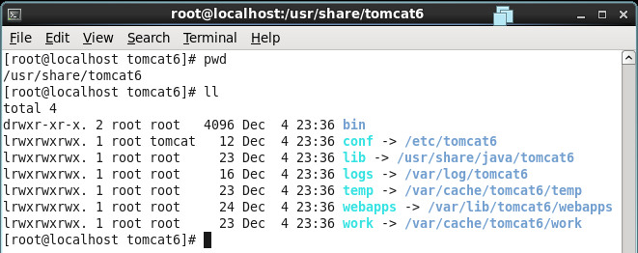

获取配置文件中有效的行

# grep -v '<!--' server.xml

更改tomcat默认的端口

conf/server.xml 将8080修改问需要的端口

3.2手动安装
定位xml配置文件

# locate server.xml | grep tomcat
/root/apache-tomcat-6.0.37/conf/server.xml

解开压缩包到指定的位置，即可

Ubuntu系统

12.04 64bit server版

启用root账号

sudo passwd root

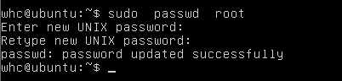

切换到root账号

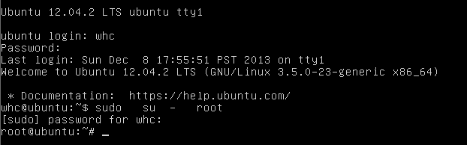

安装vim编辑软件

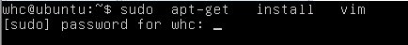

常用的apt命令

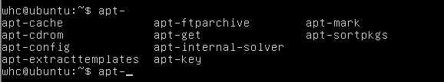

#apt-cache search string 根据名称查找软件包

#apt-cache depends fping 查找软件包fping的依赖关系

#apt-get rdepends fping 查找依赖fping的软件

只有depends才能确定真正的依赖性，反向的依赖性不一定可靠。Depends开头的是必须安装的，Recommends不是必需的。

另外apt-get install package时以Depends或是Recommends开头的行中的包都将被安装，而以Suggests开头的行中的包不会被安装。

查看软件是否成功安装

或者

备注：dpkg -l 列出所有已安装软件包列表

apt-get的用途：

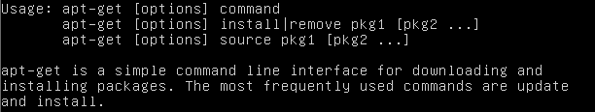

命令：

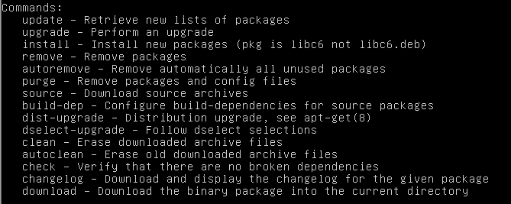

选项：

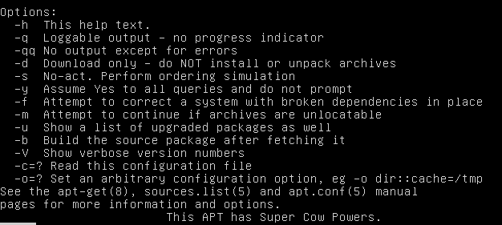

dpkg的用法：

# dpkg -L openjdk-7-jdk 查看软件的安装路径



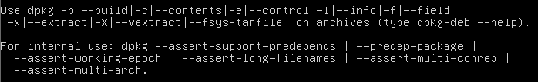

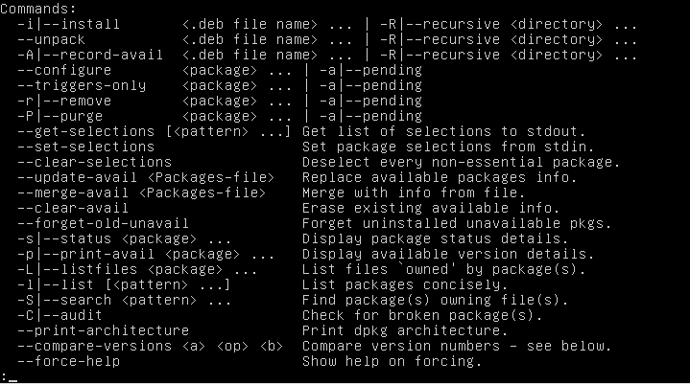

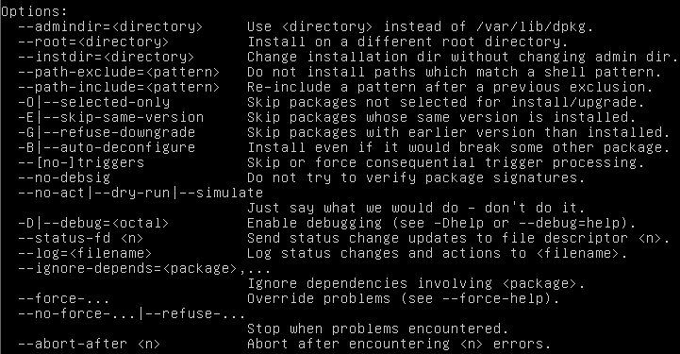

httpd的检测

1.1apt-get安装
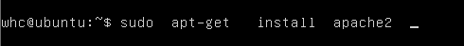

启动：sudo apache2ctl -k start
停止：sudo apache2ctl -k stop
重新启动：sudo apache2ctl -k restart
配置文件保存在：/etc/apache2

需要说明的是，普通的apache发行版本配置文件是：
httpd.conf
Ubuntu发行版本的主配置文件是：
apache2.conf
在apache2.conf引用到了以下文件：
# 包含动态模块的配置:
Include /etc/apache2/mods-enabled/*.load
Include /etc/apache2/mods-enabled/*.conf
# 包含用户自己的配置:
Include /etc/apache2/httpd.conf
# 包含端口监听的配置:
Include /etc/apache2/ports.conf
# 包含一般性的配置语句片断:
Include /etc/apache2/conf.d/
# 包含虚拟主机的配置指令:
Include /etc/apache2/sites-enabled/
主配置文件：/etc/apache2/apache2.conf

查看已安装的apache版本

# dpkg -l | grep apache | grep "metapackage" | awk '{print $2}'
apache2

查找主配置文件路径

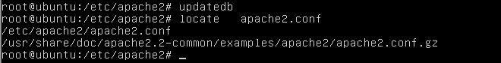

'

1.2make编译安装

下载源码

# wget http://mirrors.cnnic.cn/apache/httpd/httpd-2.2.26.tar.gz

解压源码包

# tar -zxf httpd-2.2.26.tar.gz

进入源码包目录

# cd httpd-2.2.26

编译apache

# ./configure --help

# ./configure --prefix=/usr/local/apache

# make && make install

启动http服务|停止

# /usr/local/apache/bin/apachectl start/stop

./icons #Apache图标文件目录
./modules #动态加载模块目录
./lib #库文件目录
./logs #日志文件目录
./build #
./conf #主配置文件目录
./conf/extra #扩展及模块配置文件目录
./conf/original #用于存放 extra目录和httpd.conf的备份
./error #默认错误应答文件目录
./manual #Apache文档目录
./include #包含头文件目录
./htdocs #默认WEB文档根目录
./cgi-bin #默认cgi文件目录
./bin #Apache二进制程序及服务程序目录
./man #man帮助文件目录

获取编译时的参数

# find / -name "config.nice" | grep "build"

/usr/local/apache/build/config.nice

# cat /usr/local/apache/build/config.nice

#! /bin/sh
#
# Created by configure

"./configure" \
"--prefix=/usr/local/apache" \
"$@"

#grep "prefix=" /usr/local/apache/build/config.nice

"--prefix=/usr/local/apache" \

得到编译安装的安装目录

# grep "prefix=" /usr/local/apache/build/config.nice | awk -F"=" '{print $2}' | awk -F'"' '{print $1}'

/usr/local/apache

如果没有手动指定

A typical installation might use "/usr/local/apache2" for PREFIX (without the quotes).

------------以上操作获取apache的安装目录

配置文件的路径

conf/httpd.conf

# cat htdocs/index.html 默认主页存放目录
<html><body><h1>It works!</h1></body></html>

# ls /usr/local/apache/conf/extra
httpd-autoindex.conf httpd-languages.conf httpd-ssl.conf
httpd-dav.conf httpd-manual.conf httpd-userdir.conf
httpd-default.conf httpd-mpm.conf httpd-vhosts.conf
httpd-info.conf httpd-multilang-errordoc.conf

判断vhost功能是否开启,默认不开启

# Virtual hosts
#Include conf/extra/httpd-vhosts.conf

开启的话：
- vhost 都在 httpd-vhosts.conf文件中 OK
- vhost放到了httpd.conf中，httpd-vhosts.conf中的vhost删除 OK
- httpd.conf 和 httpd-vhost.conf 中都有vhost OK
- 专门有指定了 Include 相对路径 文件、目录 绝对的文件、目录
如：
Include conf/vhost/*.conf OK

2、Nginx的检测

# apt-get install -y nginx

下载nginx
#wget http://nginx.org/download/nginx-1.4.2.tar.gz
解压nginx
# tar -zxvf nginx-1.4.2.tar.gz

目录重命名
# mv nginx-1.4.2 nginx

编译选项配置，这里从简
# cd nginx
# ./configure --prefix=/usr/local/nginx

Tomcat的检测
apt方式安装

#apt-get install -y tomcat7

手动解压

# apt-get install -y openjdk-7-jdk 安装java

/usr/lib/jvm/java-7-openjdk-i386

